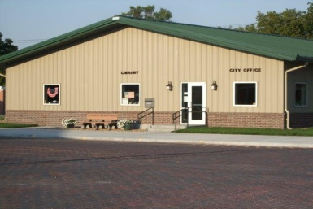

This contract confirms the agreement between the City of Almena and resident __________________________________ for the purchase of a poly cart for trash services. Poly carts cost $87.00 and payments can be made over the course of ten (10) months, four (4) months or two (2) months. Payments will be billed with your City of Almena utility bill each month and the due date will be the 15th of each month the same as your utility bill due date. If more than one cart is purchased the below payment amounts will double, triple, etc. based on the number purchased.

The agreed upon payment dates and amounts are as follows:

|  |  |
| --- | --- |
| **____/15/_____** | **🞏 $43.50 🞏 $21.75 🞏 $8.70** |
| **____/15/_____** | **🞏 $43.50 🞏 $21.75 🞏 $8.70** |
| **____/15/_____** | **🞏 $21.75 🞏 $8.70** |
| **____/15/_____** | **🞏 $21.75 🞏 $8.70** |
| **____/15/_____** | **🞏 $8.70** |
| **____/15/_____** | **🞏 $8.70** |
| **____/15/_____** | **🞏 $8.70** |
| **____/15/_____** | **🞏 $8.70** |
| **____/15/_____** | **🞏 $8.70** |
| **____/15/_____** | **🞏 $8.70** |

I agree to make payments on the specified dates and the agreed amounts recorded in the payment schedule above. I understand the consequences that will be brought against me if the contract is violated. These penalties include: late fees, repossession of the poly cart, and/or costs assessed against the property as a special tax assessment.

**SIGNED**: _________________________________________________________________________________

Print Name: ______________________________________________________________________

Phone: ___________________________________________________________________________

Address for delivery: ____________________________________________________________

Date Delivered:_________________________

*Administration:*

*Attach photo of poly cart(s) delivered, record number(s) on poly cart log.*

*Place in residents file after all payments have been verified.*

## POLY CART PAYMENT PLAN

City Office Hours

*Monday-Friday*

*8:00am-1:00pm*

Mayor

Tracy Stutsman

City Clerk

Catherine Rivera

Deputy City Clerk

Annette Puent

City Attorney

Doug Sebelius

Fire Chief

Jeff Callaway

Assistant Fire Chief

Ryan Keith

City Operator

Chandler Schnuerle

City Council

Amy Chandler

Bob Hawks

Ethan Hays

Kevin Sides

Brian Sproul

City of Almena

P.O. Box 277

421 Main Street

Almena@ruraltel.net 785-669-2425

Almena, Kansas

almena@ruraltel.net

785-669-2425