City of Almena - Direct Debit/Credit Authorization Form
For automatic payment of your City Utility Bill for Water, Sewer and Trash.

Please print and complete ALL the information below.

Name: ____________________________________________________________

Address: ____________________________________________________________

City, State, Zip: ____________________________________________________________

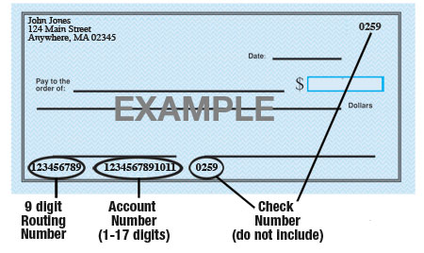

Name of Bank: ____________________________________________________________

Account #: ____________________________________________________________

9-Digit Routing #: ____________________________________________________________

Amount of Bill Monthly from Type of Account: Checking Savings (Circle One)

Please attach an unsigned, voided check for the account which you are authorizing us to debit and/or credit.

Company Name is hereby authorized to directly debit my monthly City Utility (Water, Sewer, Trash) charges from the account listed above. Should the City of Almena create a dual entry or debit the incorrect amount, this authorization also supports a direct deposit to make necessary corrections or adjustments. This authorization will remain in effect until I modify or cancel it in writing with 30-day’s notice.

Customer Signature: _______________________________________Date:________________

