APRIL 25-27TH
Please have all items sorted into categories (metals/appliances, construction/furniture, trash, etc.)
ALMENA CITY-WIDE CLEAN UP
Set out at the curb by
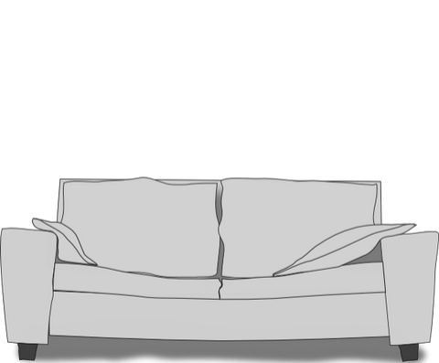
8 am MONDAY APRIL 25TH
ITEMS THAT WILL NOT BE PICKED UP:
• TIRES
• MOTOR OIL
• POISONS
• PESTICIDES
• APPLIANCES
WITH FREON
• AUTO/MARINE
BATTERIES

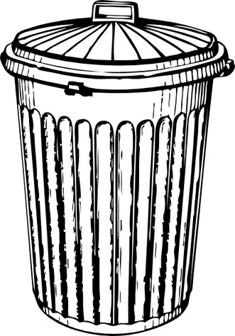
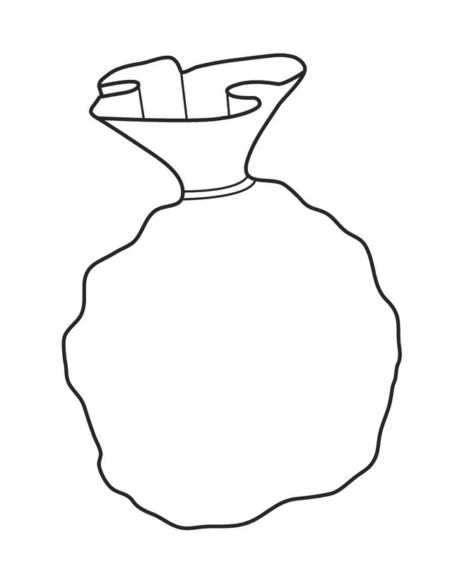
Mattresses, furniture, construction debris, appliances, & e-waste

Household Trash & Recycles

Yard Waste
Yard waste must be bagged and tied. Fireplace ash must be in plastic bags that are securely tied.
If you have questions, please call the city office (785)669-2425 or the city cell (785)669-7039

